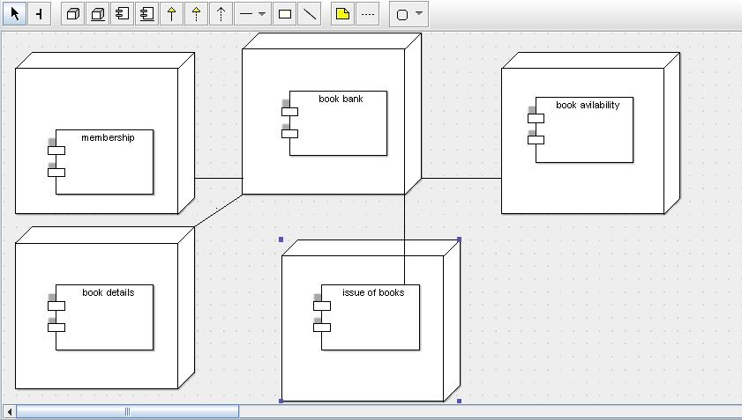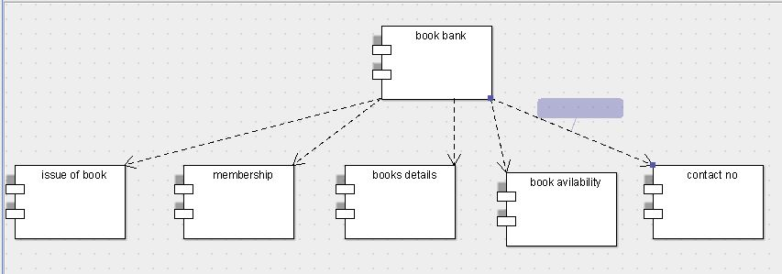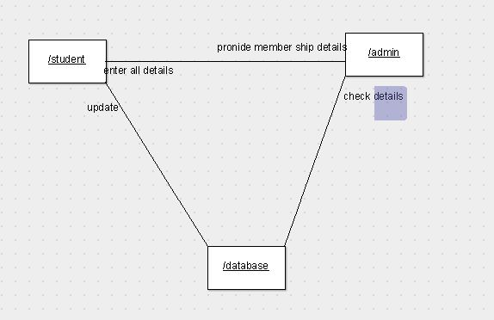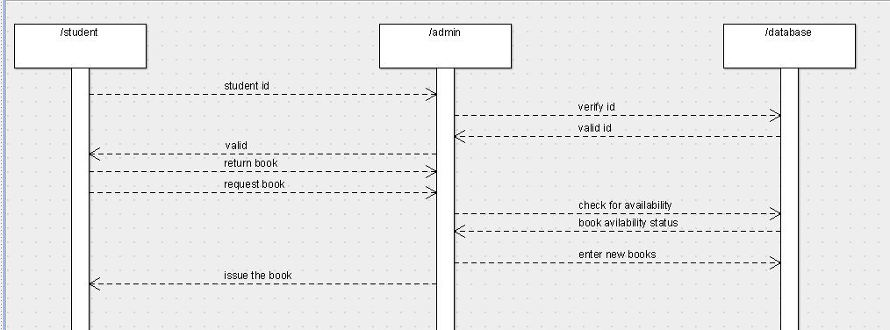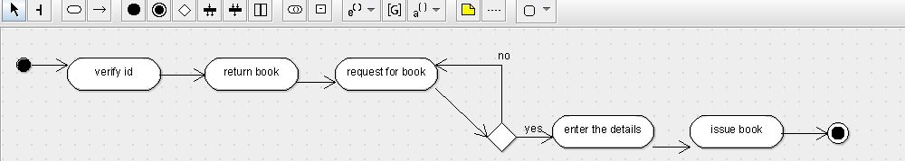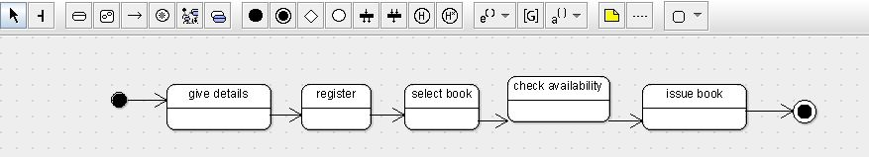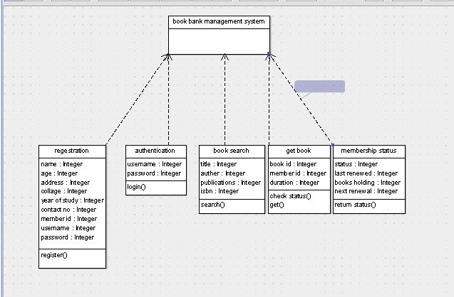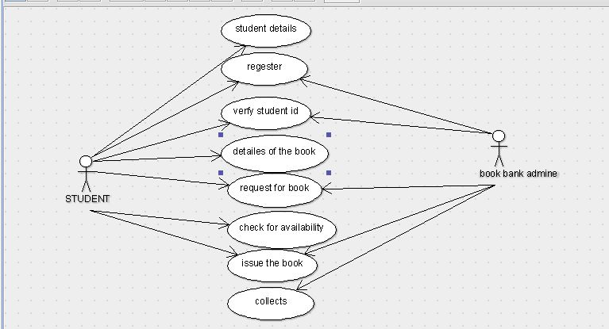

Program:-

import java.util.Vector;

public class book bank registration system {

public Vector myregistration;

public Vector myauthentication;

public Vector mybook search;

public Vector mymembership status;

public Vector myget book;

}

import java.util.Vector;

public class book search {

protected Integer title;

protected Integer auther;

protected Integer publication;

protected Integer isBn;

public Vector mybook bank registration system;

protected void search() {

}

}import java.util.Vector;

public class membership status {

public Integer status;

public Integer last renewed;

public Integer book holding;

public Integer next renewal;

public Vector mybook bank registration system;

public void retutrn status() {

}

}

import java.util.Vector;

public class authentication {

protected Integer user name;

protected Integer password;

public Vector mybook bank registration system;

protected void login() {

}

}import java.util.Vector;

class get book {

public Integer book id;

public Integer member id;

public Integer duretion;

public Vector mybook bank registration system;

public void check status() {

}

public void get() {

}

public void newOperation() {

}

}